Rest Builder :

**Introduction:**

* Rest Builder is Liferay’s tool to build REST and GraphQL APIs.
* Rest builder is a tool that can help developers generate RESTful web services quickly and easily.
* REST Builder can be used to create RESTful web services for a wide range of applications, including web applications, mobile applications, and Iot devices.

**Benefits :** The benefits of using REST Builder include:

1. Development speed:
   * you avoid writing JAX-RS annotations, converters, adding support for multipart or layers to organize your code. Everything is generated.
2. API scaffolding:
   * pagination, filtering, searching, JSON writers, XML generation, even unit, and integration tests are generated.
3. GraphQL support out of the box:
   * write your REST API and get a GraphQL endpoint for free.
4. JSON & XML support:
   * APIs return whichever format the consumer prefers.
5. Flexibility:
   * REST Builder allows developers to customize the generated code to meet their specific needs.

**Prerequisites :**

* Liferay 7.x
* Basic understanding of Liferay
* Knowledge of API

**Environmental Requirements :**

* Liferay
* Eclipse IDE
* Blade CLI
* Gradle

**Generating APIs with REST Builder**

Follow these steps to REST Builder to create a headless REST API for your apps:

1. Create a project.
   1. Open eclipse IDE. Select the desired workspace which is created for your project and then click on launch.
2. Navigate to the File → New → Other.. → Liferay Workspace Project → Enter Project name → Select Build type → Select Product Version → Then click on Finish tab. Open a new project window.
3. Now create a new REST Builder module project
4. Navigate to the Project name  → Right click on Modules → New → Liferay Module Project and Click on “Next”
5. Enter Project name
6. Select “Build type” as “Gradle”  → Select “Project Template name” as “REST Builder” → Then click on “Next”
7. Open a new window. Enter Component class name  → Enter Package name → Click on “Finish”
8. The necessary file structure for Rest Builder automatically gets created as below.

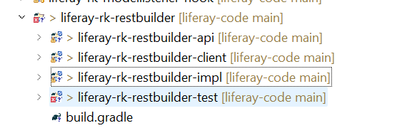

1. In your *-impl module’s root folder, write your OpenAPI profile in **“rest-openapi.yaml”** file.  
   Writing YAML files is tricky, so you can use the swagger editor to do it, which validates the YAML file against YAML syntax and the OpenAPI specification.
2. Once you have written your OpenAPI configuration and profile, it’s time to generate your scaffolding for REST and GraphQL.
3. Now Build the REST Builder module.  
   In the terminal, navigate to the root directory of your rest-builder project  
   Execute the below command to build the rest-builder module
4. After implementing all the business logic for each service, execute below command to deploy your rest-builder module

Check your api –

http://localhost:8080/o/api